How to Create a Stock and Flow Model with Multiple Elements, Actions and features

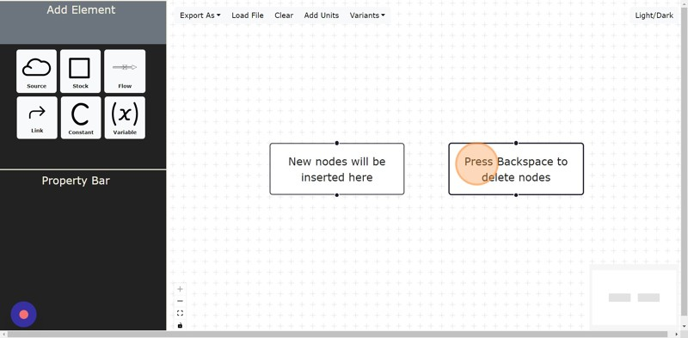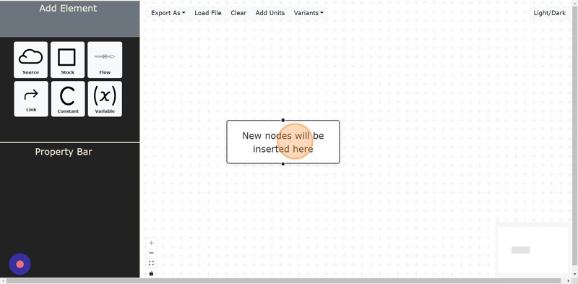

**1**

Navigate to localhost:3000

Click " **BACKSPACE**" to delete nodes

Click **"ADD UNITS"** Button Click the **"ENTER A UNIT"** field.

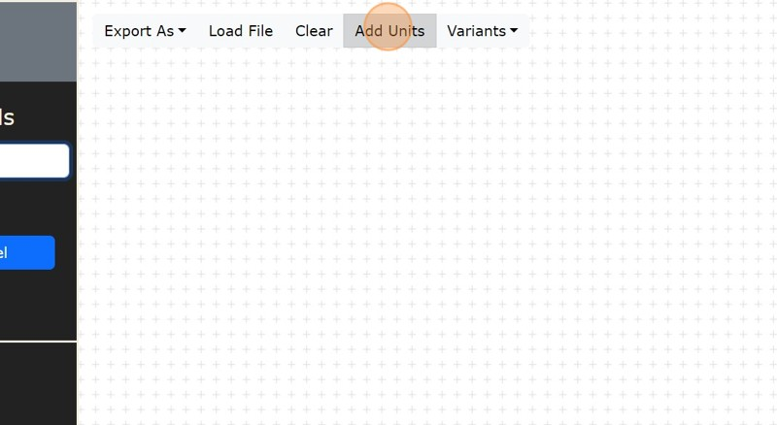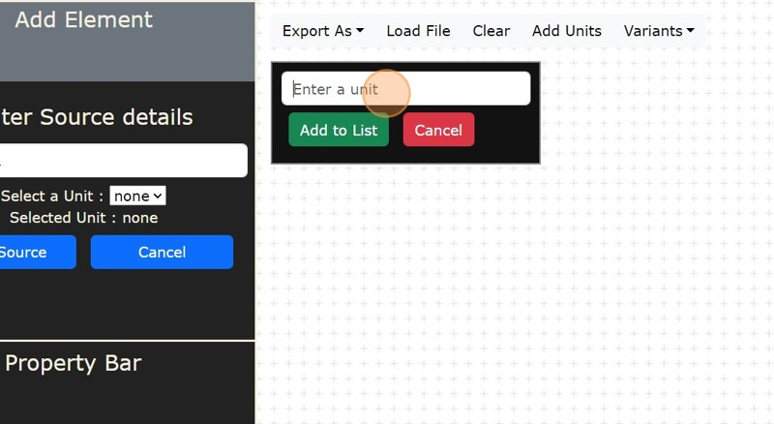

**2**

Type any unit you want to use, Example : **"KG"**

Click **"ADD TO LIST"** to add in unit list Click **"CANCEL"**

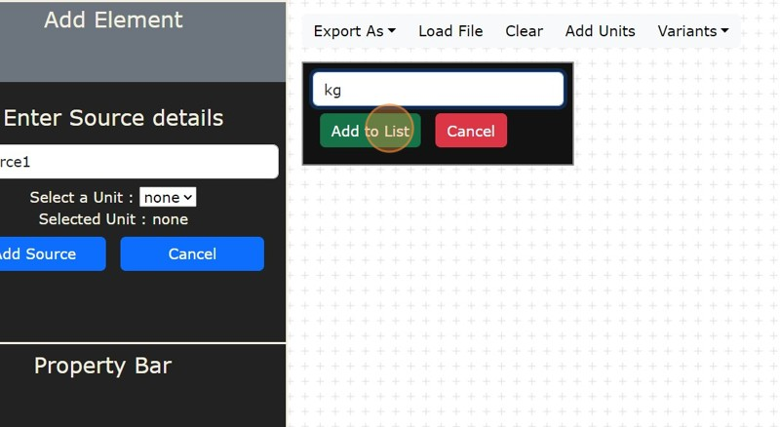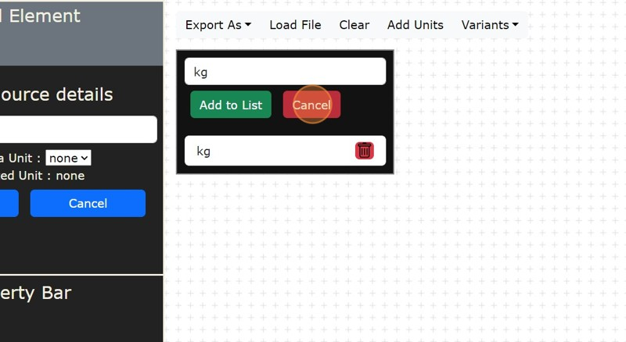

**3**

Click this **"SOURCE"** icon Button.

Then Click the **"ENTER LABEL NAME"** field.

Type any name you want to give to the source for Example : **"SOURCE1"** Then Click this dropdown **"SELECT UNIT"** you want to give which you added before in add unit section.

Then Click **"ADD SOURCE"**.

Your **"SOURCE1"** is on Screen now .

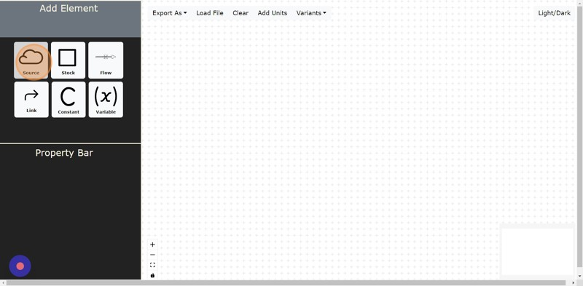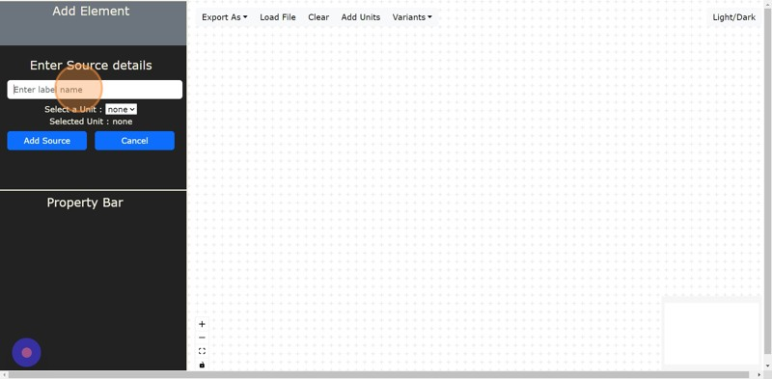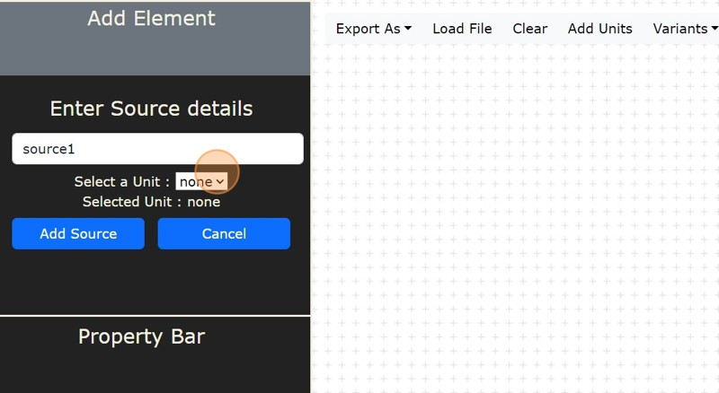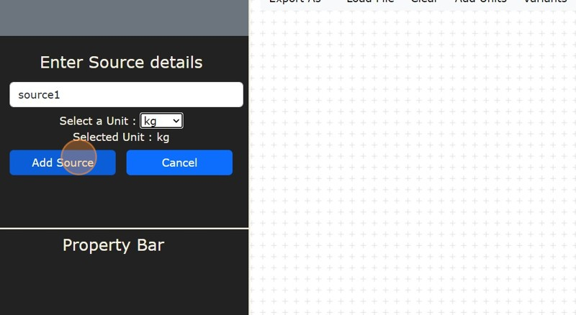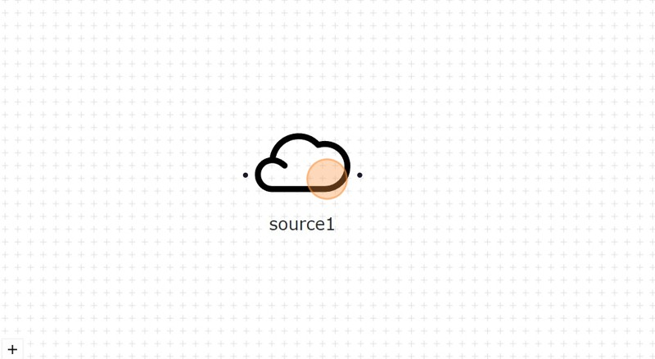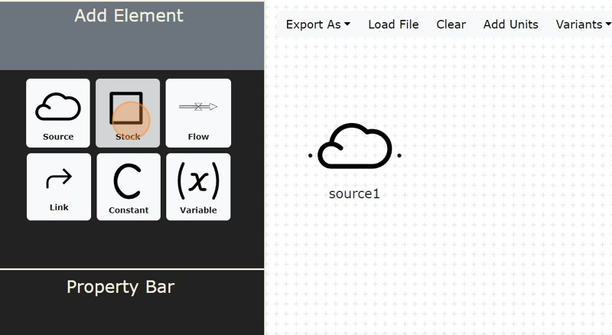

**4**

Click this **"STOCK"** icon Button.

Then Click the **"ENTER LABEL NAME"** field.

Type any name you want to give to the stock for Example: **"STOCK1"**

Then Click the **"ENTER VALUE"** field.

Type any value you want to give for Example: "10"

Then Click this dropdown**"SELECT UNIT"** you want to give which you added before in add unit section.

Then Click **"ADD STOCK"**

Your **"STOCK1"** is on Screen now .

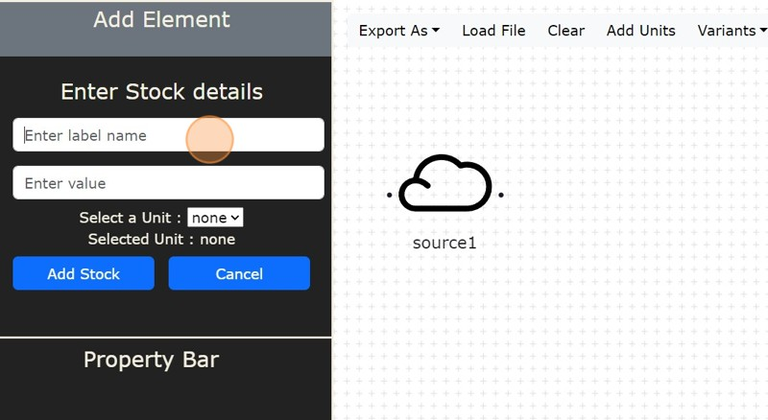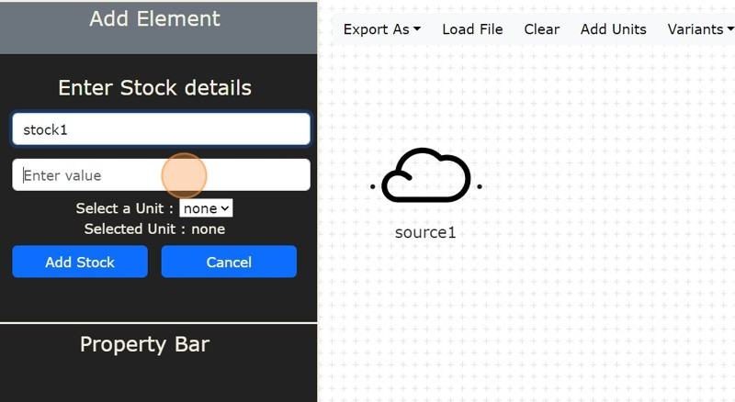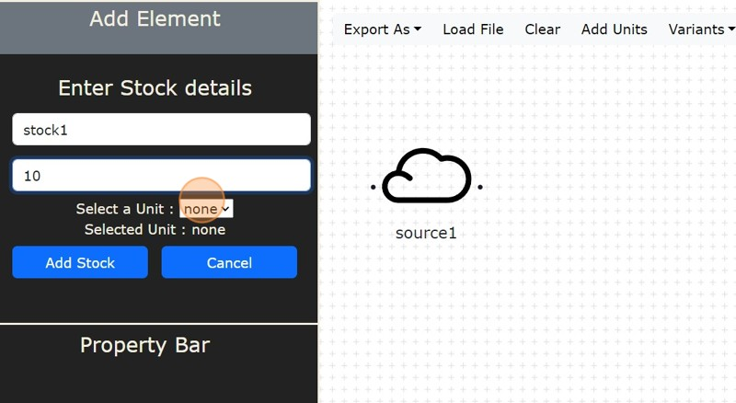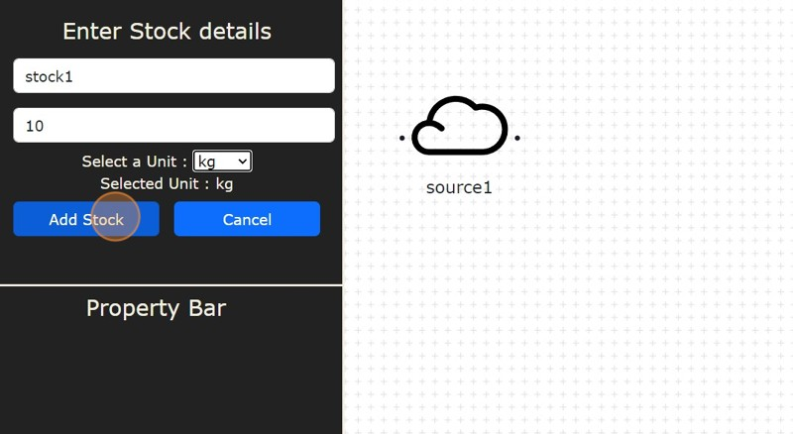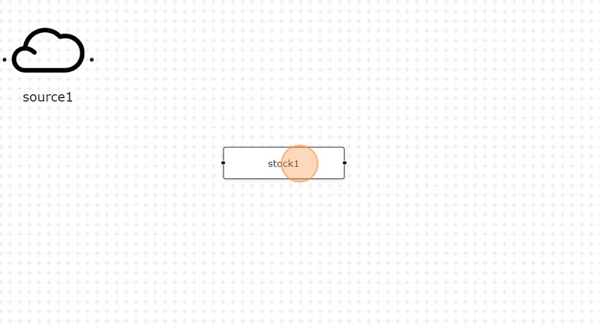

**5**

Click this **"FLOW"** Icon button.

Then Click the **"ENTER LABEL NAME"** field.

Type any name you want to give to the Flow for Example: **"FLOW1"**. Then Click **"SOURCE"** dropdown which is for selecting source of the flow, Then Click **"TARGET"** dropdown which is for selecting Target of the flow. Then Click the **"ENTER VALUE"** field.

Type any value you want to give for Example "15" Then Click the **"ENTER EQUATION"** field.

Type equation which includes factors which have role in flow1

Then Click this dropdown **"SELECT UNIT"** you want to give which you added before in add unit section.

Click **"ADD FLOW"**

Your **"FLOW1"** is on Screen now.

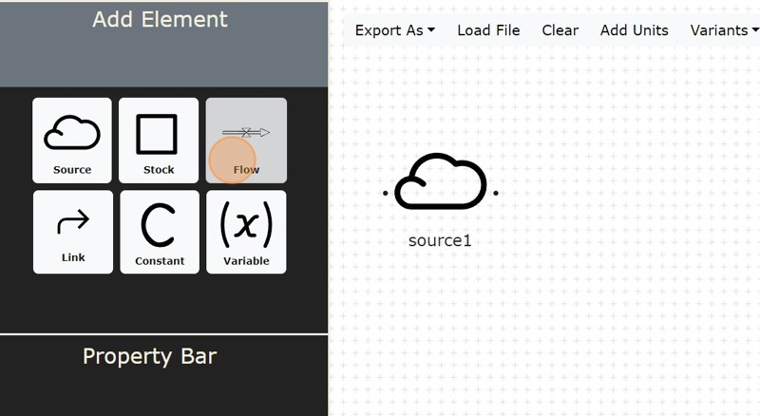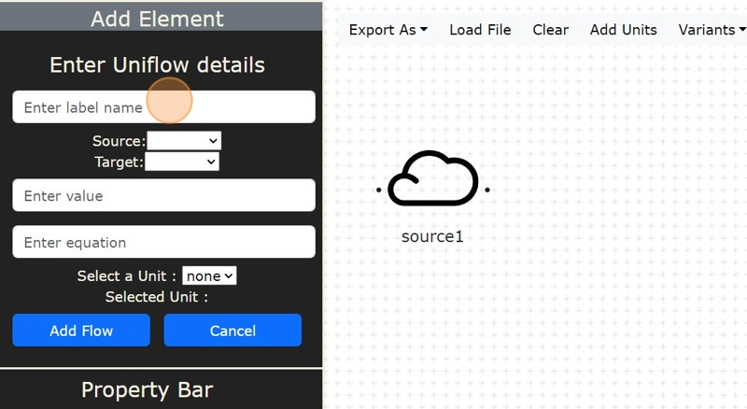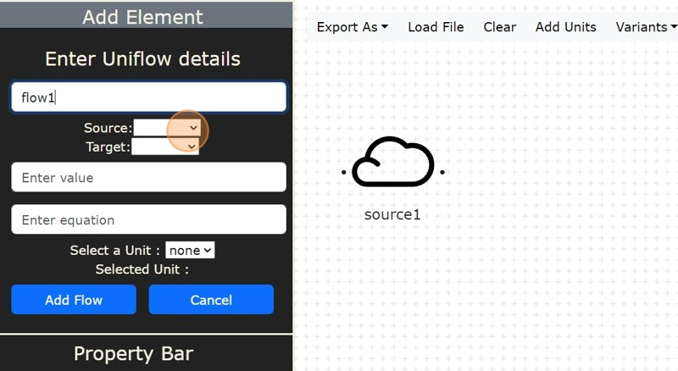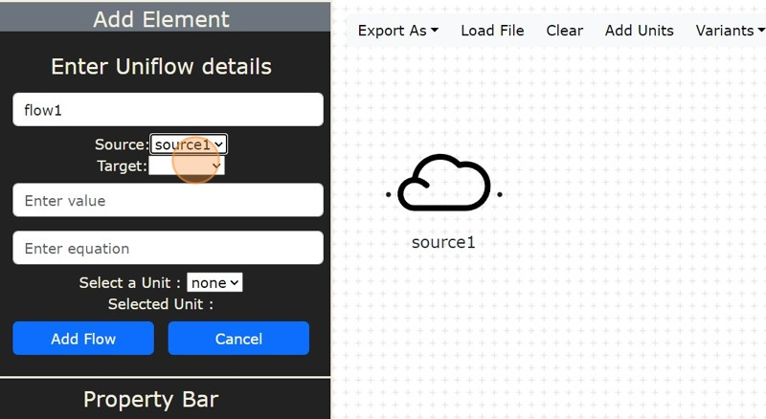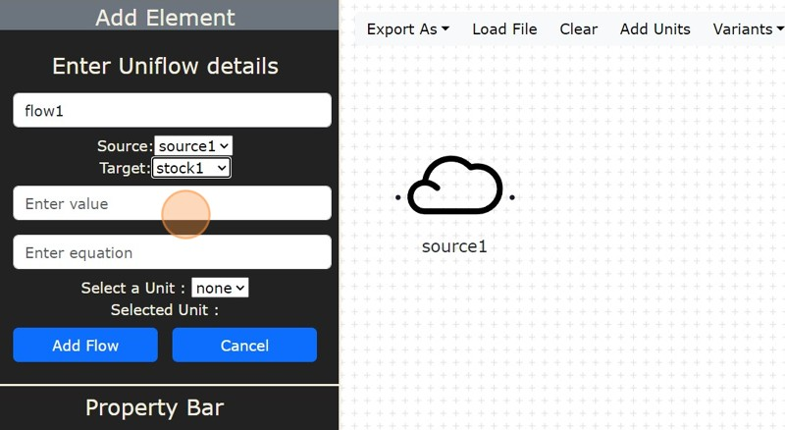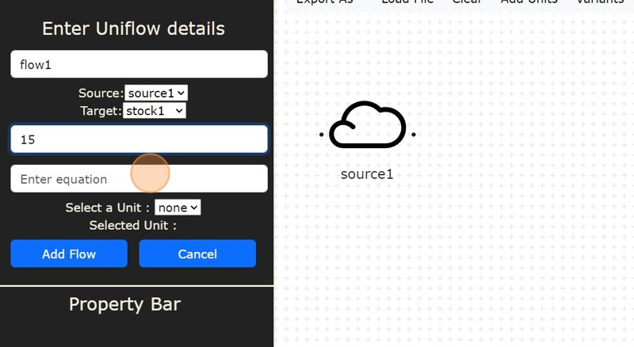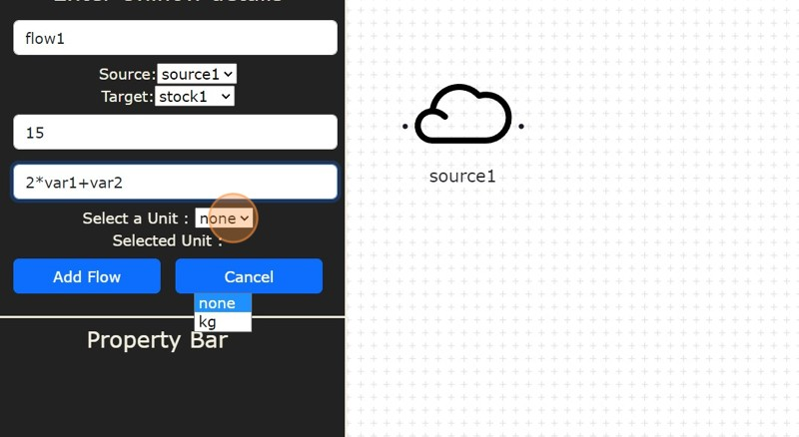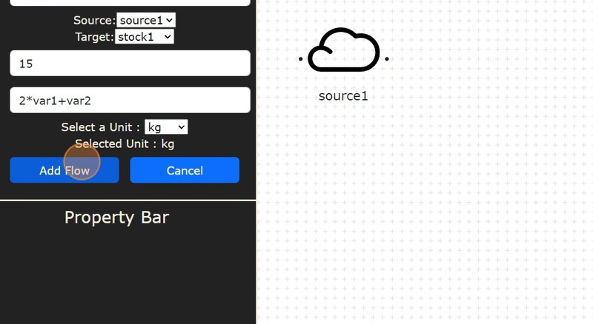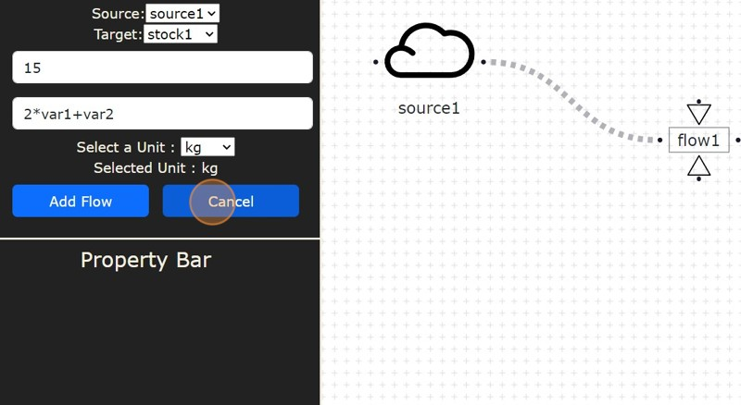

**6**

Click this **"VARIABLE"** Icon Button. Click the **"ENTER LABEL NAME"** field.

Type any name you want to give to the Variable for Example: **"VAR1"**. Then Click the **"ENTER VALUE"** field.

Type any value you want to give for Example: "20". Then Click the **"ENTER EQUATION"** field.

Type equation which includes factors which have role in var1

Then Click this dropdown **"SELECT UNIT"** you want to give which you added before in add unit section.

Click **"ADD VARIABLE"**.

Your **"VAR1"** is on Screen now.

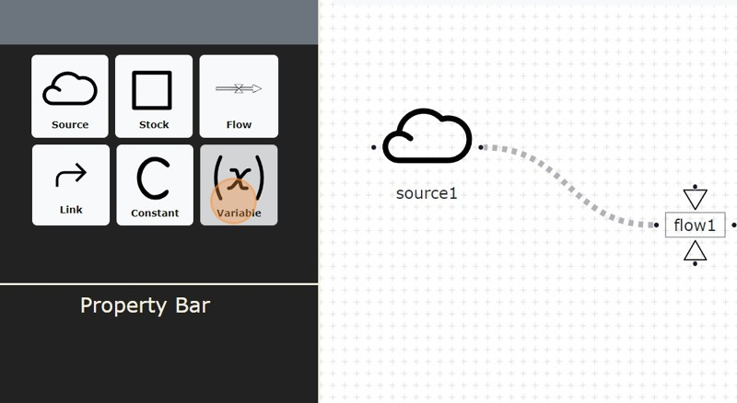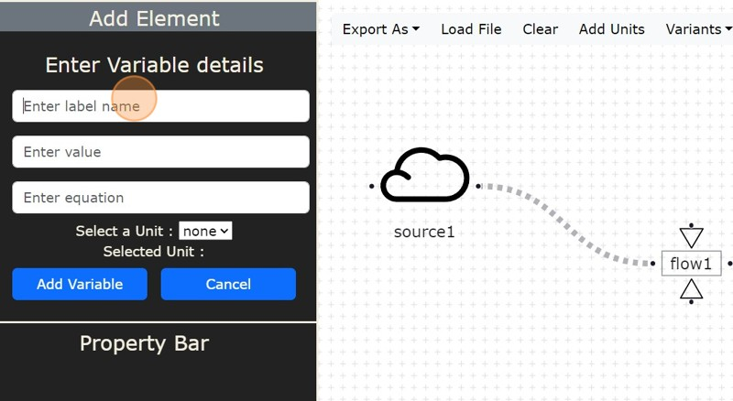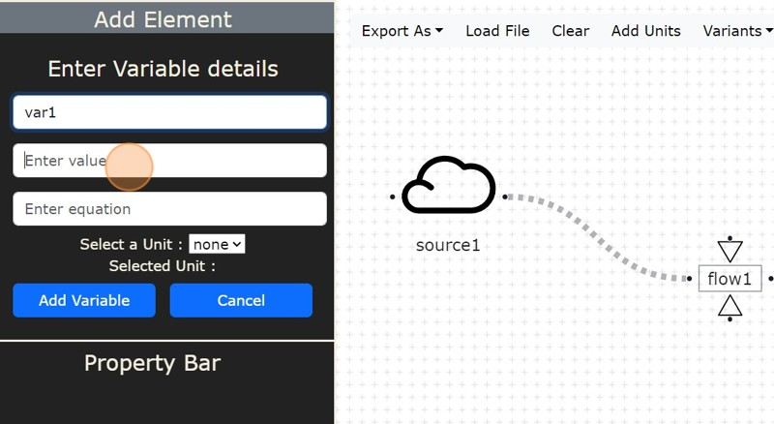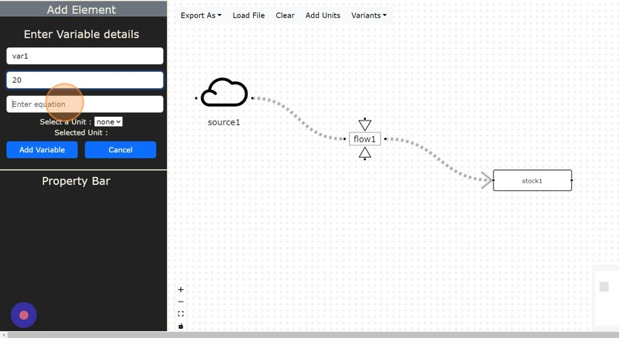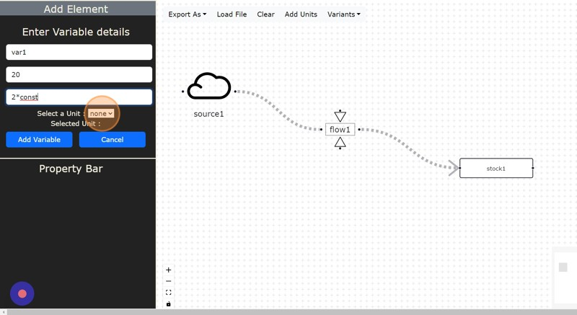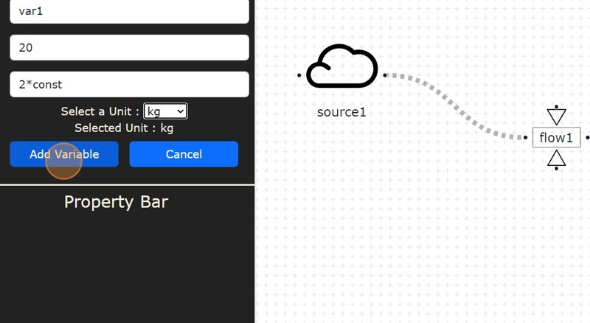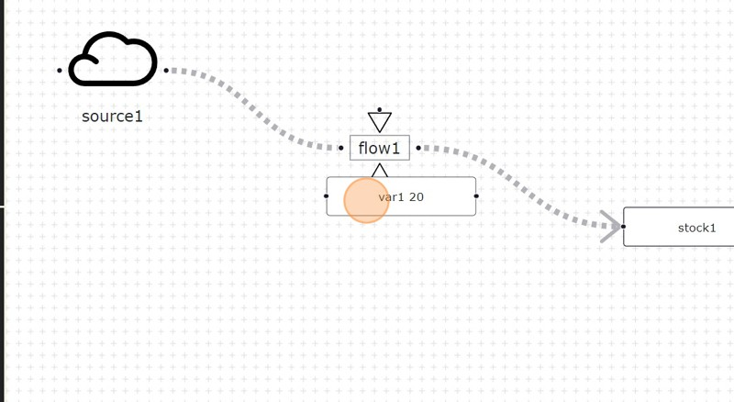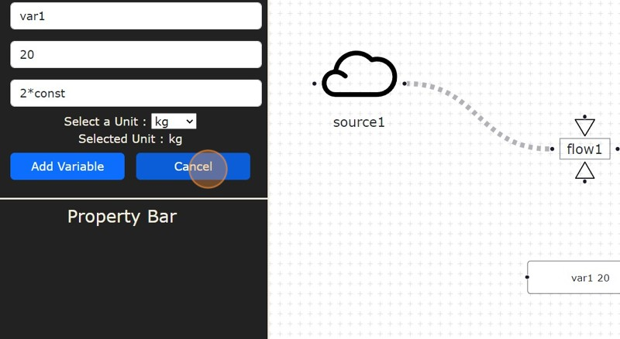

**7**

Click this **"CONSTANT"** icon Button.

Then Click the **"ENTER LABEL NAME"** field.

Type any name you want to give to the stock for Example: **"CONST1"**. Then Click the **"ENTER VALUE"** field.

Type any value you want to give for Example: "22"

Then Click this dropdown **"SELECT UNIT"** you want to give which you added before in add unit section.

Then Click **"ADD CONSTANT"**. Your **"CONST1"** is on Screen now .

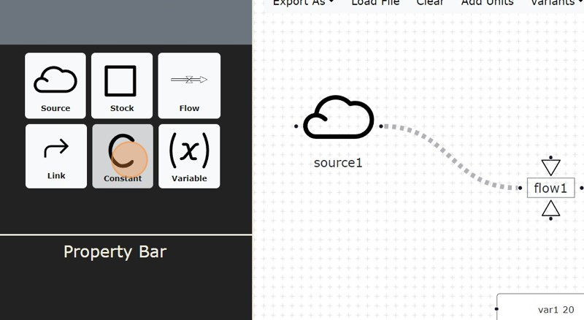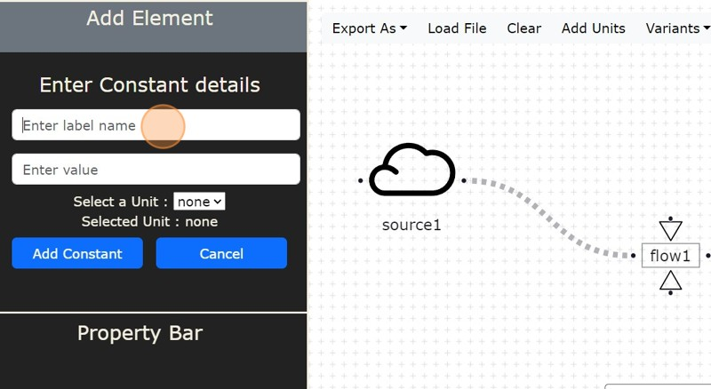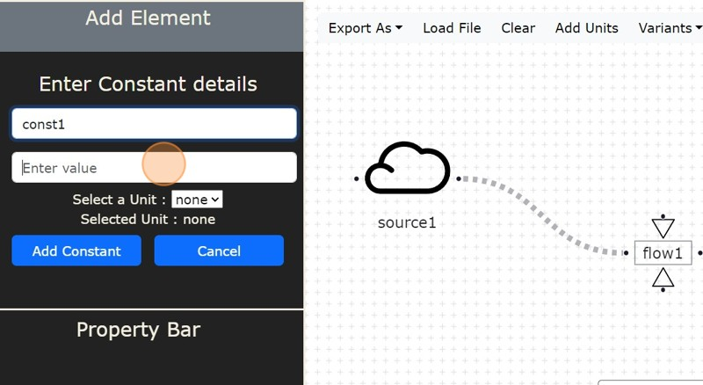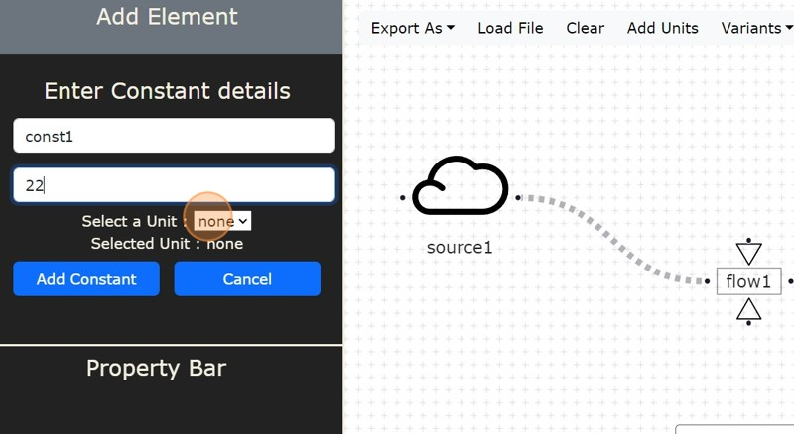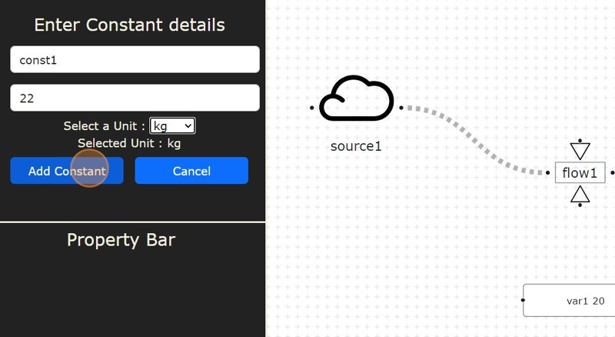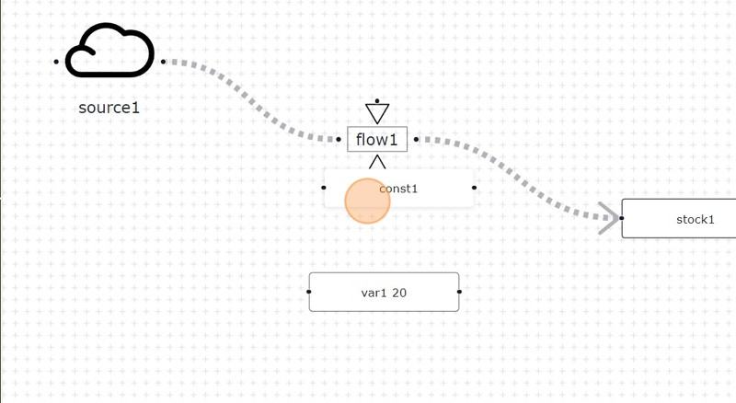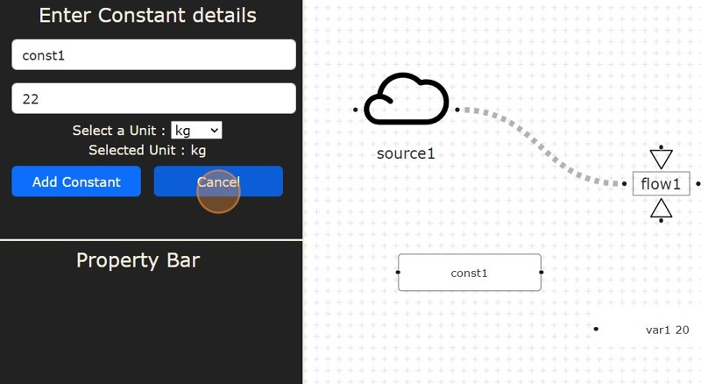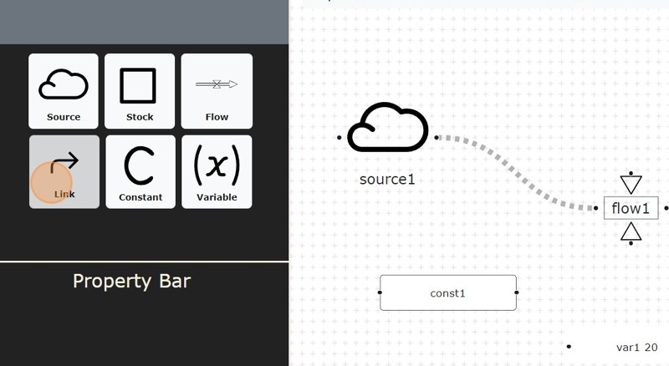

**8**

Click this **"LINK"** Icon button.

Then Click the **"ENTER LABEL NAME"** field.

Type any name you want to give to the Link for Example: **"LINK1"**.

Then Click **"SOURCE"** dropdown which is for selecting source of the Link. Then Click **"TARGET"** dropdown which is for selecting Target of the Link. Then Click **"ADD LINK"**

Your **LINK1** is on Screen now.

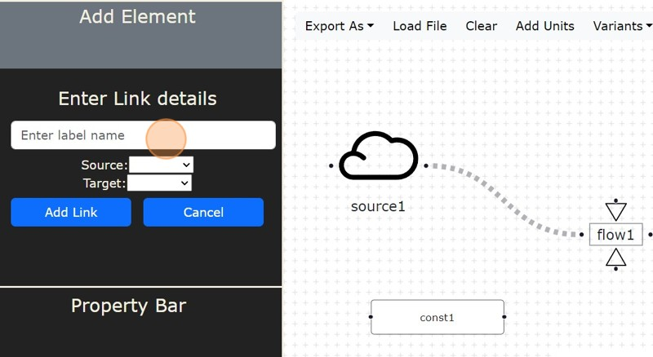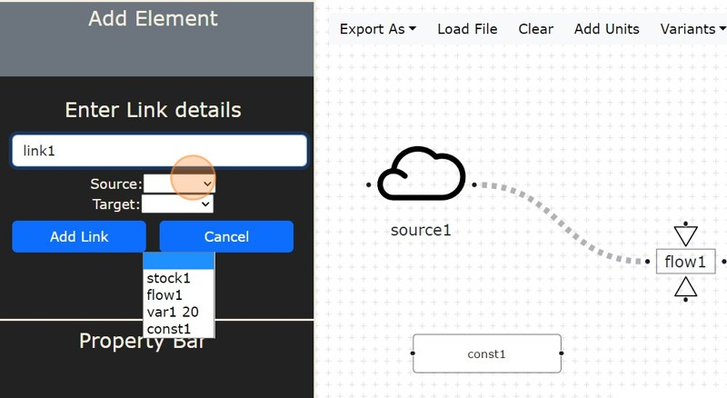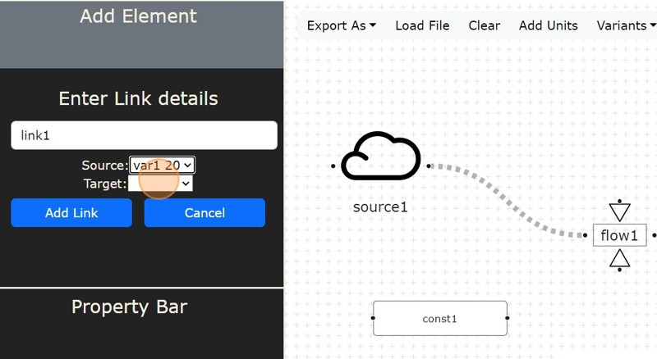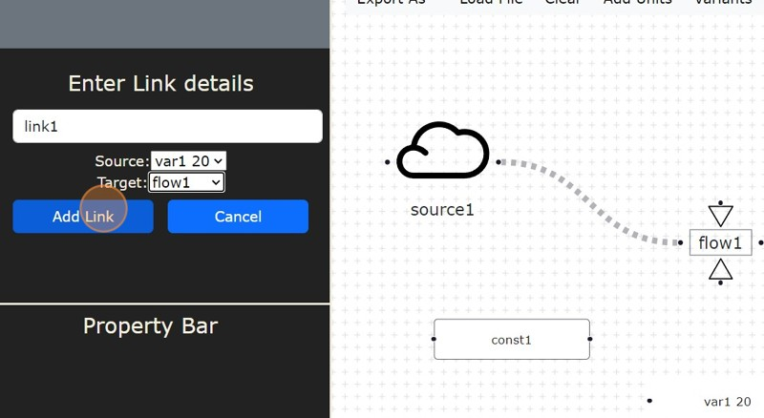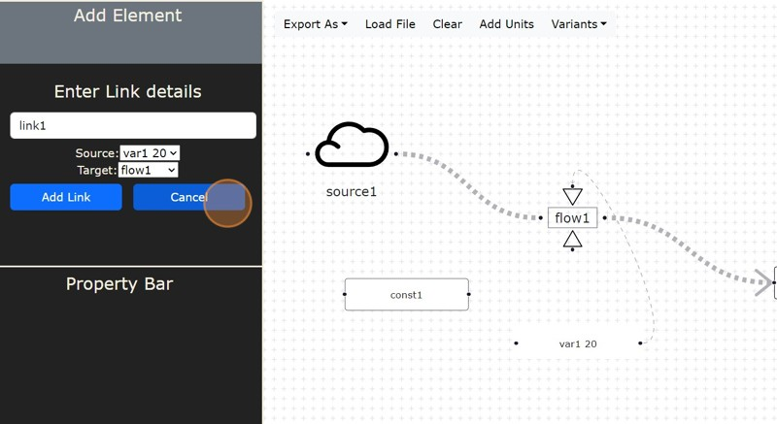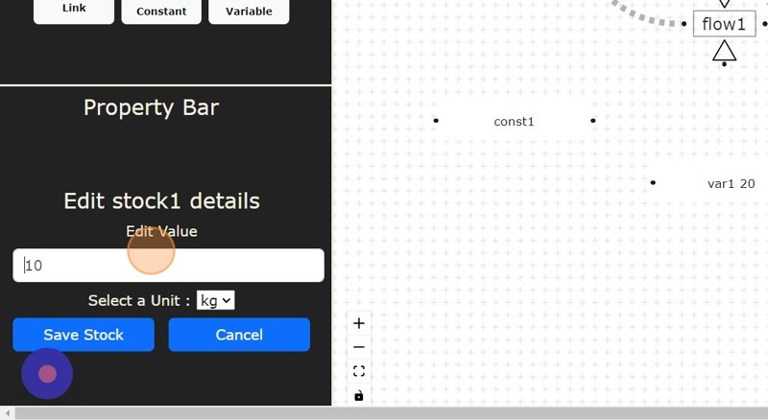

**9**

After creating Elements on canvas section screen if you want to edit its values just

**"CLICK ON THAT ELEMENT"** you get Pop up in **"PROPERTY BAR" "EDIT VALUE"**

and the **"SAVE"** it for further use.

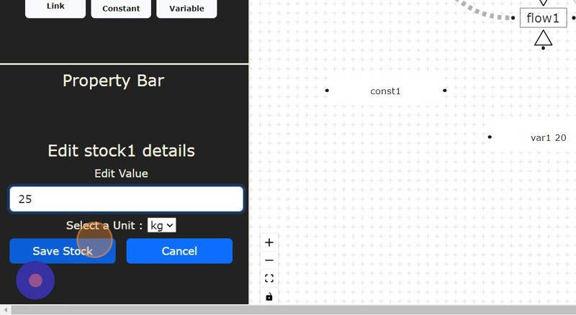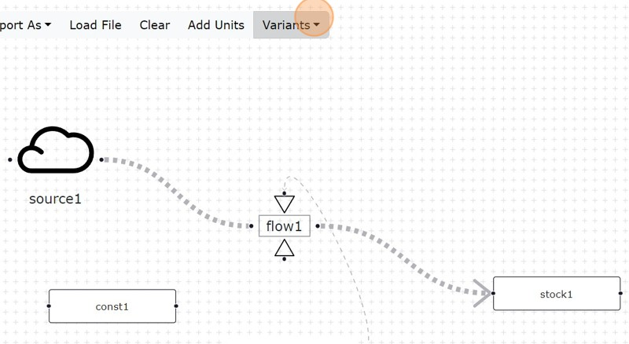

**10**

Click **"VARIANTS"**Dropdown Button which have 3 sections which change Background variants.

Click **"LINES"** Button to change background as lines. Click **"CROSS"** Button to change background as cross. Click **"DOTS"** Button to change background as dots.

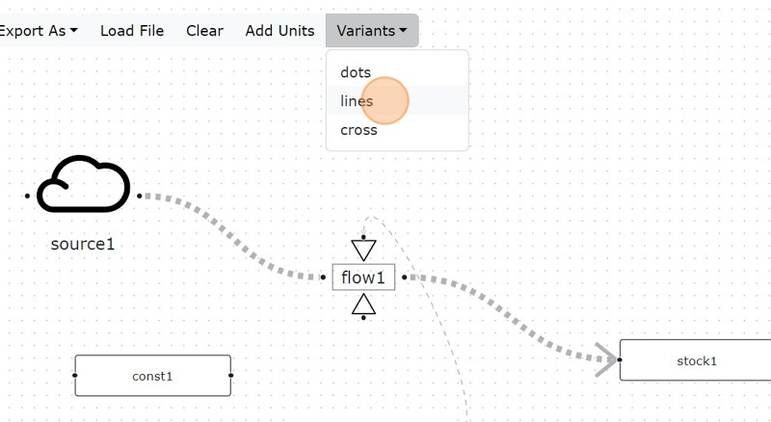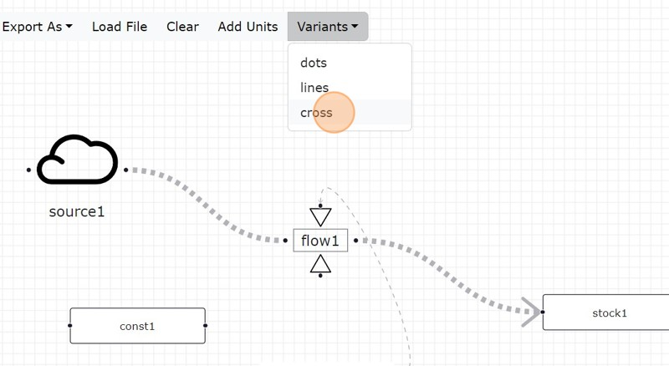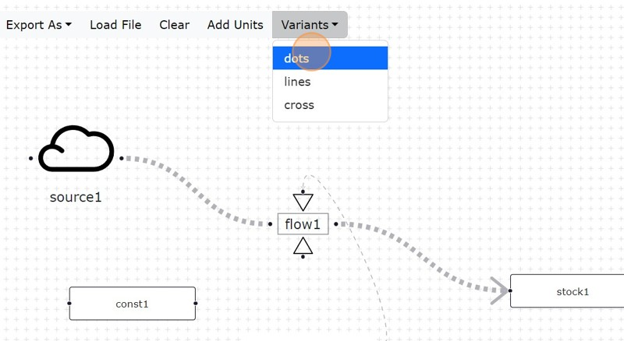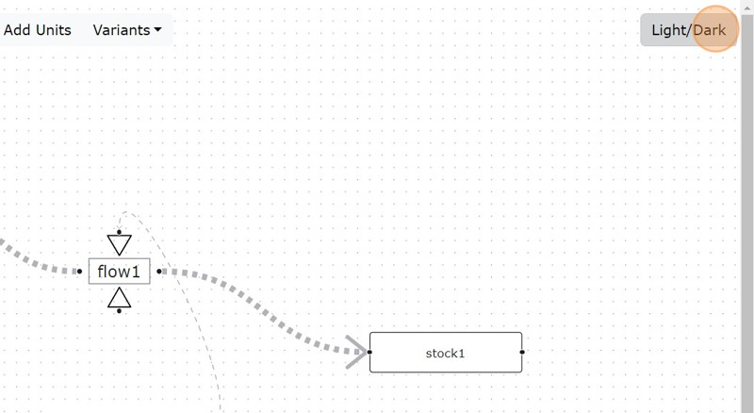

**11**

Click **"LIGHT/DARK"** Button which changes the Theme of the Canavas section screen from light to dark and vise-versa.

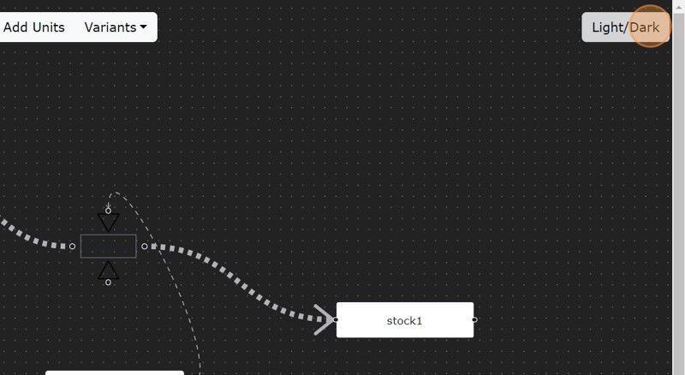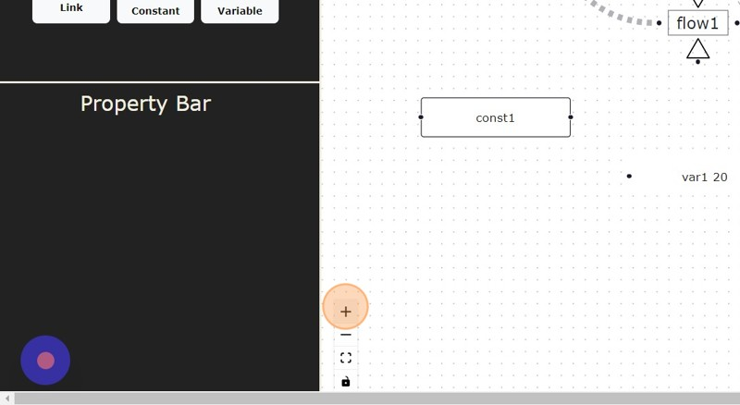

**12**

This is **"CONTROL"**which have 4 sections which represents functionality on canvas section screen :

Click this **"+"** icon Button to Zoom In. Click this **"-"** icon Button to Zoom Out. Click this [["[ ]"]] icon Button to Fit View. Click this **"LOCK"** icon Button to Lock.

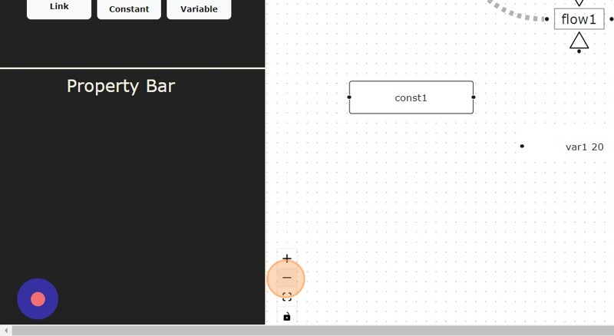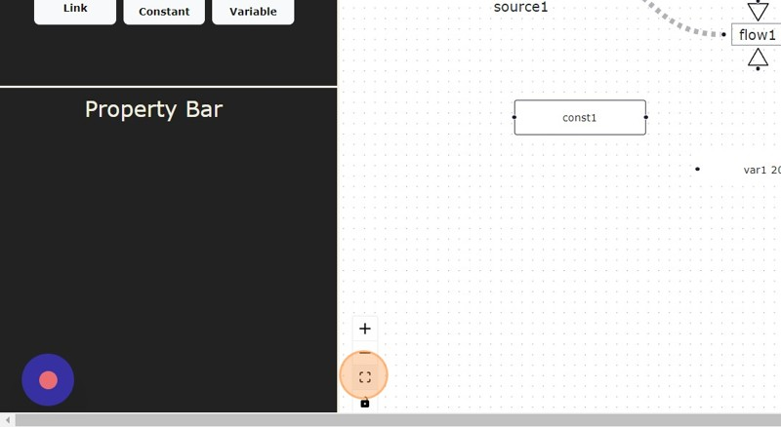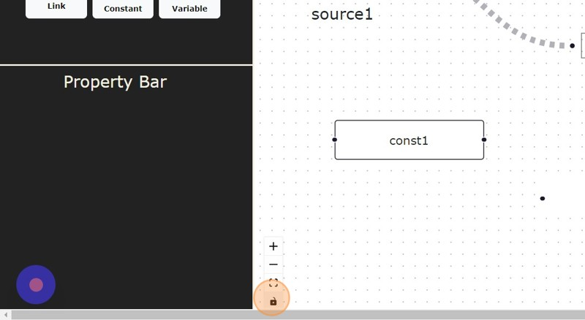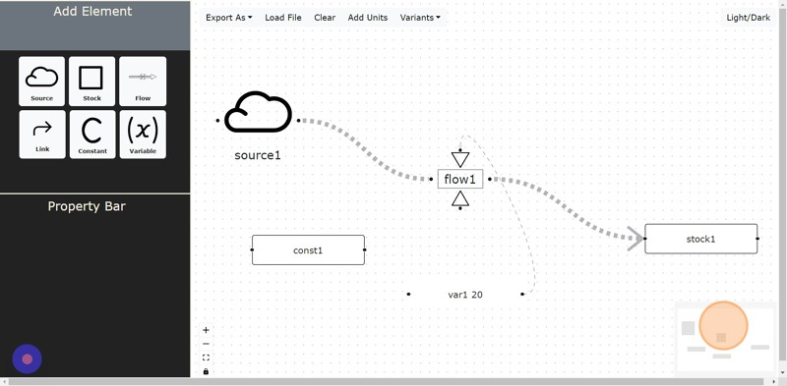

**13**

Click this Right Corner **"MINIMAP"** you can visit to overall canvas section screen on single click without much drag and scroll.

**14**

Here on Click **"RIGHT MOUSE"** Button you can select the any portion of the Model and drag to the place where you want to place it.

And then on Click **"LEFT MOUSE"** Button you can drag the background of canvas section screen.

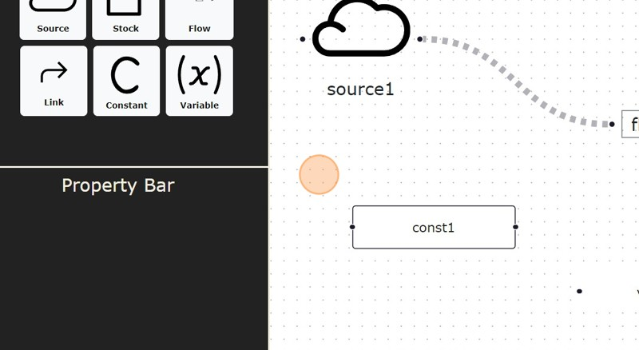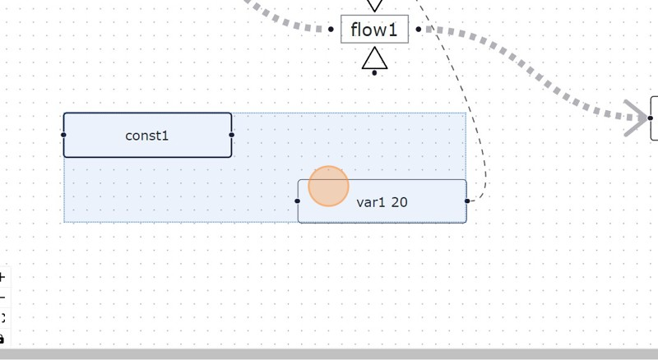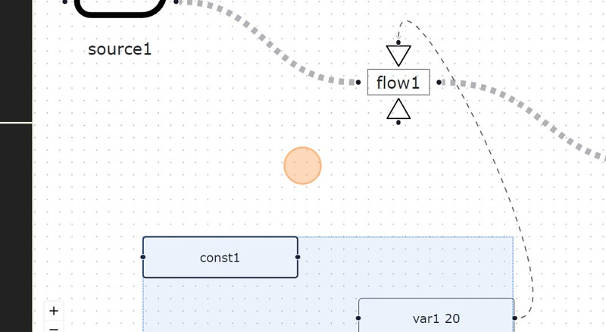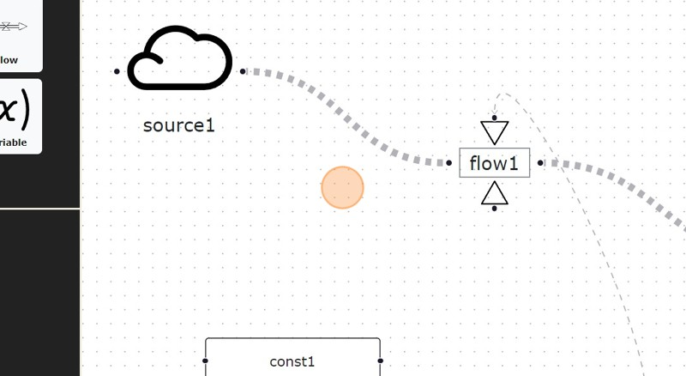

**15**

Click **"EXPORT AS"** Dropdown Button :

Then Click **"EXPORT AS JSON"** to Export the Model as JSON file. Then Click **"EXPORT AS PNG"** to Export the Model as PNG file.

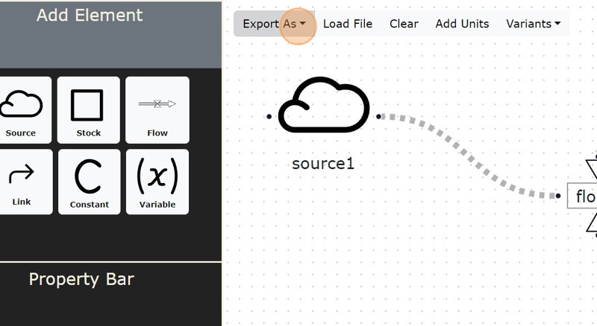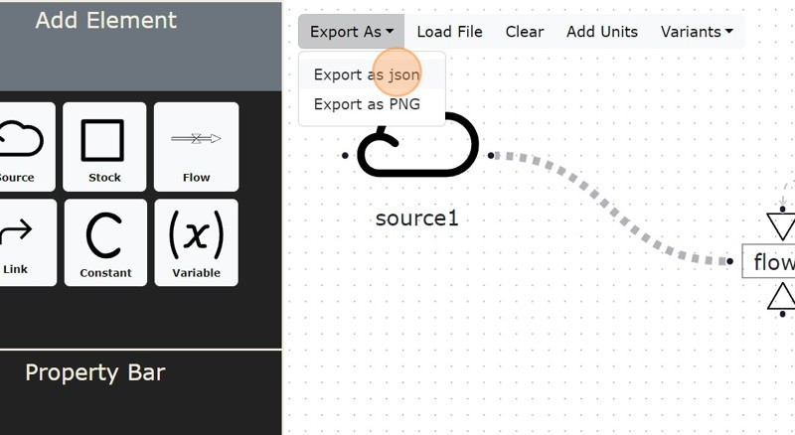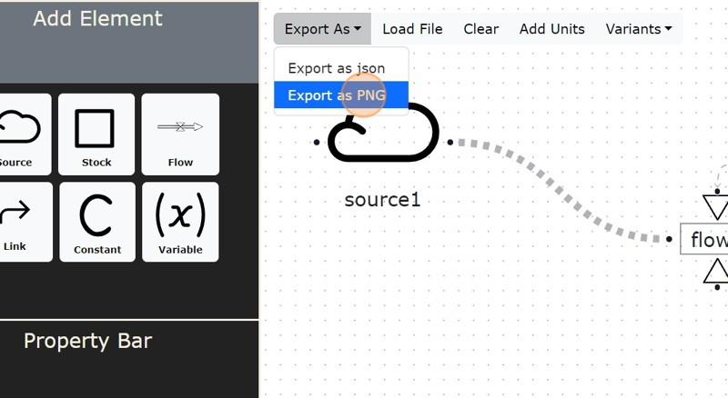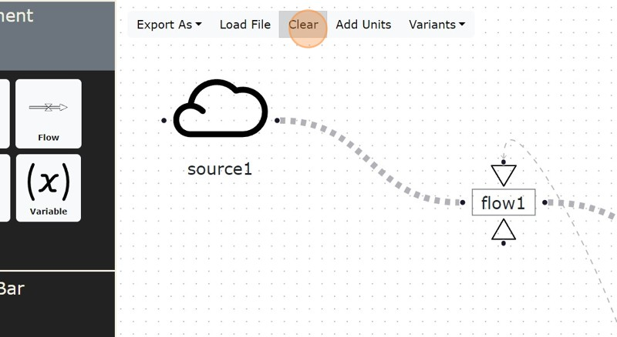

**16**

Click **"CLEAR"** Button to clear the canvas section screen of the stock and flow model.

Click **"LOAD FILE"** Button to Load JSON file which renders the JSON based stock and flow model on canvas section screen.

Now on Click any Element in Model you can Edit that and **"RESTRUCTURE"**

Previous Loaded Model

